

**==Submitted By==**

Ushna Nadeem (21i-1225)

Murtaza Hasan (21i-1137)

Fatima Fateen (20i-2328)

**==Course Instructor==**

Sir Atif Jilani

**May 7th, 2023 ☺**

***RedDrop – A Blood Bank Management System***

Contents

Work Division Table 3

Version History Table 4

1 Project Scope 4

2 Actor Goal List 4

3 Use Case Diagram 7

4 High Level Use Cases 9

4.1 Registration 9

4.2 Set Appointment 9

4.3 Generate Reports 9

4.4 Display Optimal Meal 10

4.5 Enable Cross Matching Record 10

4.6 Set Reminder 11

4.7 Generate Rewards 11

4.8 View Donation History 11

4.9 View Blood Tests 12

4.10 Maintain Transfusion Reaction 12

4.11 Display Chart of Individuals with Most Donations 12

4.12 Send Alerts 13

5 Expanded Use Cases 13

5.1 Set Appointment 13

5.2 Generate Reports 15

5.3 Display Optimal Meal 17

5.4 Enable Cross Matching Record 18

5.5 View Donation History 20

5.6 View Blood Tests 22

5.7 Send Alerts 24

5.8 Maintain Transfusion Reaction 26

5.9 Set Reminder 27

6 Wireframes 29

7 Java FX Frames 34

8 System Sequence Diagrams (SSD) 39

8.1 Set Appointment 39

8.2 Generate Report 40

8.3 Display Optimal Meal 41

8.4 Enable Cross Matching Record 42

8.5 View Donation History 42

8.6 View Blood Test Result 43

8.7 Send Alerts 44

8.8 Maintain Transfusion Reaction 45

8.9 Set Reminder 46

9 Sequence Diagrams (SD) 46

9.1 Set Appointment 46

9.2 Generate Report 49

9.3 Display Optimal Meal 50

9.4 Enable Cross-Matching Record 51

9.5 View Donation History 54

9.6 View Blood Test Result 55

9.7 Send Alerts 57

9.8 Maintain Transfusion Reaction 60

9.9 Set Reminder 61

10 Domain Model (DM) 63

11 Class Diagram (CD) 63

# Work Division Table

|  |  |
| --- | --- |
|  |  |
| **Ushna Nadeem (21i-1225)** | 7 High Level Use Cases, 3 Expanded Use Cases, 3 Wireframes, 2 JavaFx Interfaces, 3 System Sequence Diagrams, Domain Model, Sequence Diagrams of respective SSD’s, Class Diagram, Code, Document Proofreading/Editing and Submission. |
| **Murtaza Hasan (21i-1137)** | 2 High Level Use Cases, Actor Goal List, 3 Expanded Use Cases, 3 Wireframes, 2 JavaFx Interfaces, 3 System Sequence Diagrams and Domain Model, Sequence Diagrams of respective SSD’s, Class Diagram, Code. |
| **Fatima Fateen (20i-2328)** | 2 High Level Use Cases, Project Scope, Use Case Diagram, 3 Expanded Use Cases, 3 Wireframes, 2 JavaFx Interfaces, Updated Use Case Diagram, 3 System Sequence Diagrams and Domain Model, Sequence Diagrams of respective SSD’s, Class Diagram, Code. |

# Version History Table

|  |  |
| --- | --- |
|  |  |
| **March 4th, 2023 (A02)** | Version 01 |
| **March 20th, 2023 (A03)** | Version 02 (Updated UC Diagram) |
| **April 12th, 2023 (A04)** | Version 03 |
| **May 8th, 2023 (A05)** | Version 04 (Updated SSD Diagrams) |
| **May 7th, 2023 (Final)** | Version 05 (Updated and Revised Document) |
|  |  |

# Project Scope

The RedDrop is a software application designed to manage the activities of a blood bank. The scope of RedDrop includes functionalities such as donor registration, blood inventory management, blood testing, cross matching, issue management, user management and reporting. The system aims to ensure the safe and efficient management of blood units while maintaining accurate records and complying with regulatory requirements. With the help of RedDrop, blood banks can manage their operations efficiently, reduce errors, and ensure the availability of blood units for patients in need.

# Actor Goal List

|  |  |  |  |
| --- | --- | --- | --- |
| **Actor** | **Goal** | **Actor** | **Goal** |
| Donor | * Register * View history * Request appointments * View rewards * View diet plan * View notifications * View blood tests | System | * Register user and blood banks * Authenticate credentials while registering * Generate rewards * Maintain and show donation history of donors * Maintain and update the chart of donors with most donations * Check for blood available in different centers when required * Send out reminders * Maintain transfusion reaction Information |
| Blood Banks Management | * Register * Keep a check on bank performance * Donor demographics * Transfusion volumes. * Maintain inventory levels | Blood Banks Staff | * Enter donation details in system * Verify donor’s eligibility * Schedule appointments * Generate reports * Consults with medical professionals * View donor’s history * Request to display chart for individuals with most donations |
| Regulatory Bodies | * Ensure the hygiene of donation centers * Make sure that the donation centers comply with safety and quality standards * Investigate and address any safety or quality concerns related to blood products * Maintain accurate reports |  |  |

# Use Case Diagram

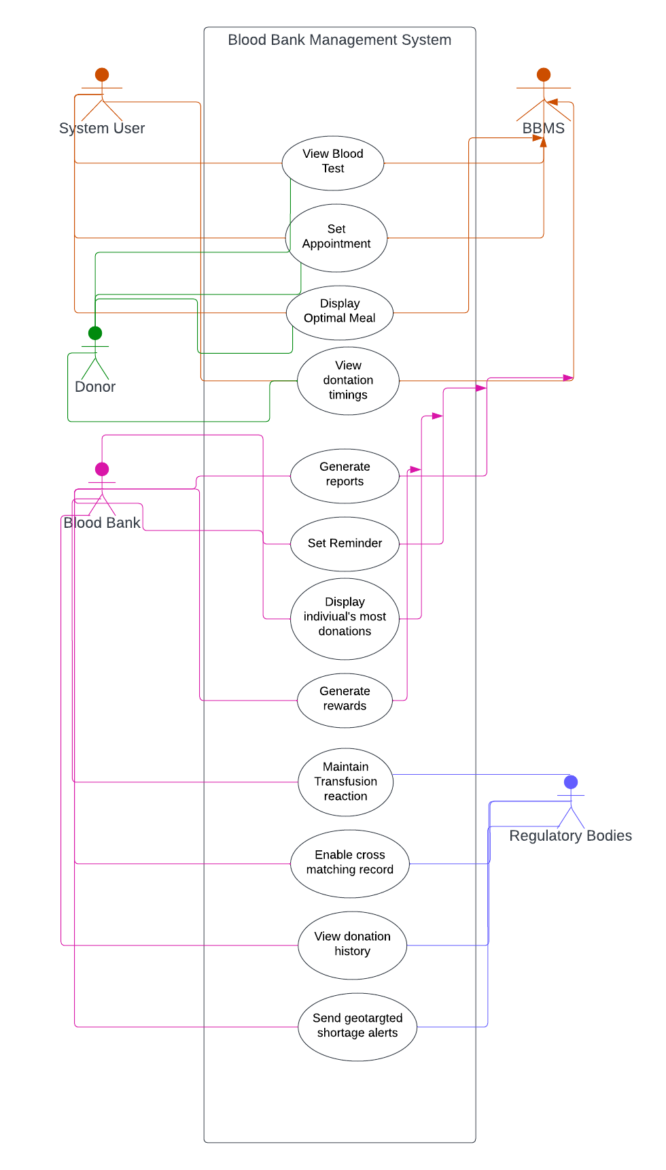

# 

# High Level Use Cases

## 4.1 Registration

|  |  |
| --- | --- |
|  | |
| **Use Case:** | Registration |
| **Actors:** | Donor, Blood bank Management |
| **Type:** | Primary |
| **Description:** | The application allows individuals to register as blood donors by providing their basic details, such as blood group and allergies, and verifying their credentials against reliable sources. Once the verification process is complete and the individual is deemed eligible, they will be registered as a donor and provided with a unique username and password. Similarly, blood banks can also register themselves by providing their details, which will be verified for credibility. If they meet the requirements, the blood bank will be granted access to all the features of the application. |

## 4.2 Set Appointment

|  |  |
| --- | --- |
|  | |
| **Use Case:** | Set Appointment |
| **Actors:** | Donor, Blood Bank Staff |
| **Type:** | Primary |
| **Description:** | When a donor requests an appointment, the system creates a blood donation appointment at the closest blood bank or hospital while verifying the donor’s previous donation records. The staff verifies the donor’s eligibility to approve and schedule the appointment, and then provides further instructions to the donor via a direct message to their account. |

## 4.3 Generate Reports

|  |  |
| --- | --- |
|  | |
| **Use Case:** | Generate Reports |
| **Actors:** | Blood Bank Staff, Medical Professionals, Regulatory Authorities, Management |
| **Type:** | Primary |
| **Description:** | The staff selects the type of report to be generated and specifies the date range, report format and other relevant parameters. The system generates reports based on the selected parameters. Medical professionals then request specific reports related to blood transfusion or donation operations, which the staff generate and provide to them. The generated reports are also provided to regulatory authorities and blood bank management to analyze bank’s performance, donor demographics, transfusion volumes and inventory levels. |

## 4.4 Display Optimal Meal

|  |  |
| --- | --- |
|  | |
| **Use Case:** | Display Optimal Meal |
| **Actors:** | Donor, Blood Bank Staff, Medical Professionals |
| **Type:** | Primary |
| **Description:** | The donor requests guidance on the optimal meal to consume before blood donation by accessing the system. The staff verifies donor’s information, such as age, weight and medical history. The staff consults with medical professionals to develop the optimal meal plan for the donor. The system generates a personalized meal plan for the donor and displays it through a web interface or mobile application. The donor can view the personalized meal plan. |

## 4.5 Enable Cross Matching Record

|  |  |
| --- | --- |
|  | |
| **Use Case:** | Enable Cross Matching Record |
| **Actors:** | Blood Bank Staff, System |
| **Type:** | Primary |
| **Description:** | The system is capable of accessing blood reports and samples from various donors and blood banks when there is a need for blood. Additionally, the system maintains comprehensive records of all donated and received blood, as well as the current availability of blood units. |

## 4.6 Set Reminder

|  |  |
| --- | --- |
|  | |
| **Use Case:** | Set Reminder |
| **Actors:** | System, Donor |
| **Type:** | Primary |
| **Description:** | The system will send text messages and pop-up notifications to the donor at the scheduled donation time. The donor has the option to turn off or mute the notifications if they find them bothersome. |

## 4.7 Generate Rewards

|  |  |
| --- | --- |
|  | |
| **Use Case:** | Generate Rewards |
| **Actors:** | Blood Bank Staff, System, Donor |
| **Type:** | Primary |
| **Description:** | Once the staff enters the donor’s donation details into the system, the system generates rewards such as certificates of appreciation recognition, or discount vouchers based on the donor’s performance evaluated against predetermined criteria. These rewards are then assigned to the donor’s account, where he/she can view it. |

## 4.8 View Donation History

|  |  |
| --- | --- |
|  | |
| **Use Case:** | View Donation History |
| **Actors:** | Donor, Blood Bank Staff, System |
| **Type:** | Primary |
| **Description:** | The system enables both donor and staff to access a donor’s blood donation history. However, in the case of donor requests, the staff verifies the donor’s identity by requesting personal information. If the verification is successful, the staff grants access to the donor’s blood donation history. The system retrieves the history from the database and display it through an interface, where donors can view and download it for their personal records. |

## 4.9 View Blood Tests

|  |  |
| --- | --- |
|  | |
| **Use Case:** | View Blood Tests |
| **Actors:** | Donor |
| **Type:** | Primary |
| **Description:** | The blood test reports for a donor can be accessed online by logging into the system. Upon logging in, the donor will be able to view their blood test reports on the screen. |

## 4.10 Maintain Transfusion Reaction

|  |  |
| --- | --- |
|  | |
| **Use Case:** | Maintain Transfusion Reaction |
| **Actors:** | System, Medical Professionals, Blood Bank Staff |
| **Type:** | Primary |
| **Description:** | Before accepting a blood donation from a donor, the staff will check the donor’s donation history. If there is a history of previous transfusion reactions, the medical professional will be consulted. Any information regarding transfusion reactions will be recorded in the system for future reference. |

## 4.11 Display Chart of Individuals with Most Donations

|  |  |
| --- | --- |
|  | |
| **Use Case:** | Display Chart Of Individuals With Most Donations |
| **Actors:** | Blood Bank Staff, System |
| **Type:** | Primary |
| **Description:** | The staff member logs into the system and selects the “Display chart for individuals with most donations”. The staff specifies the time period for which the chart needs to be generated. The system retrieves the data from the database, generates and displays the individuals with the most donations during the specified time period. The chart is displayed on the screen, and the staff can download/save it for future reference or to recognize and reward the donors who have made significant contributions to the blood bank. |

## 4.12 Send Alerts

|  |  |
| --- | --- |
|  | |
| **Use Case:** | Send Alerts |
| **Actors:** | System, Donor, Blood Bank Management |
| **Type:** | Primary |
| **Description:** | Donors are alerted of nearby blood banks based on their current location through the system, following the management’s announcement of a blood requirement. |

# Expanded Use Cases

## 5.1 Set Appointment

|  |  |
| --- | --- |
|  |  |
| **Use Case Section** | **Comment** |
| Use Case Name* | Set Appointment. |
| Scope | RedDrop. |
| Level | User Goal. |
| Primary Actor* | Donor. |
| Stakeholders and Interests | * Donor: Interested in scheduling a blood donation appointment. * Blood Bank Staff: Interested in managing blood donation appointments and ensuring that they are adequately staffed to meet demand. |
| Pre-Conditions | * The donor must be registered in the RedDrop system. * The donor must be eligible to donate blood. * There must be available appointment slots for the requested date and time. |
| Success Guarantee (Post-Conditions) | The donor’s appointment is scheduled and added to the RedDrop system. |
| Main Success Scenario* | |  |  | | --- | --- | | Actor Action | System Response | | The donor logs into the RedDrop system. |  | | The donor selects the “Make Appointment” option. |  | |  | The system presents the donor with available dates and times for appointments. | | The donor selects a date and time for the appointment. |  | |  | The system confirms and add the appointment. | |
| Extensions* | * If the donor is not registered in the RedDrop system:  1. The system prompts the donor to register before scheduling the appointment.  * If the donor is not eligible to donate the blood:  1. The system does not allow the donor to schedule an appointment.  * If there are no available appointment slots for the requested date and time:  1. The system asks the donor to select a different date and time. |
| Special Requirements | The RedDrop system must be able to schedule and add the appointments. |
| Technology and Data Variations List | * The RedDrop system must be compatible with the donor’s device. * The RedDrop system must be able to access the donor’s registration information and appointment history. * The RedDrop system must be able to display available appointment slots in real-time. |
| Frequency of Occurrence | Depends on the number of donors using the RedDrop system and the availability of appointment slots. |
| Miscellaneous | The RedDrop system must adhere to privacy and security regulations to protect donor information. |
|  |  |

## 5.2 Generate Reports

|  |  |
| --- | --- |
|  |  |
| **Use Case Section** | **Comment** |
| Use Case Name* | Generate Reports. |
| Scope | RedDrop. |
| Level | User Goal. |
| Primary Actor* | Blood Bank Staff. |
| Stakeholders and Interests | * Blood Bank Staff: Interested in efficiently generating reports, including donor analysis, hospital analysis and regulatory compliance reports. * Blood Bank Management: Interested in having staff generate reports that provide insights into blood inventory management. |
| Pre-Conditions | * The RedDrop system is up and running. * The blood bank staff is authenticated and authorized to access the RedDrop system. * The blood inventory data is up-to-date and accurate. |
| Success Guarantee (Post-Conditions) | * The blood bank staff can generate reports on blood inventory management. * The staff can view and analyze the reports. |
| Main Success Scenario* | |  |  | | --- | --- | | Actor Action | System Response | | The blood bank staff selects the “Generate Reports” option. |  | |  | The system displays a list of available report types. | | The staff selects the desired report type. |  | |  | The system retrieves the required data from the blood inventory database and generates the report. | |  | The system displays the report on the screen or provides an option to download it. | | The staff can view and analyze the report to gain insights into blood inventory management. |  | |
| Extensions* | * If the required data is not available in the database:  1. The system displays a message indicating the unavailability of data.  * If the blood bank staff encounters any issues while generating or viewing the report:  1. The system provides an option to contact technical support. |
| Special Requirements | * The RedDrop system should have the capability to generate reports on blood inventory management. * The RedDrop system should ensure the confidentiality and privacy of donor and blood inventory data. |
| Technology and Data Variations List | * The RedDrop System can use different reporting tools and technologies to generate reports. * The RedDrop system can provide options to customize the report such as selecting the time period, report format, and data filters. * The RedDrop system should ensure data interoperability between different blood bank systems. |
| Frequency of Occurrence | Can be performed on a regular basis or as and when the need arises. |
| Miscellaneous | Generating reports is crucial in ensuring efficient and effective blood inventory management in blood banks. |
|  |  |

## 5.3 Display Optimal Meal

|  |  |
| --- | --- |
|  |  |
| **Use Case Section** | **Comment** |
| Use Case Name* | Display Optimal Meal. |
| Scope | RedDrop. |
| Level | User Goal. |
| Primary Actor* | Blood Bank Staff. |
| Stakeholders and Interests | * Blood Bank Staff: Interested in efficiently managing the meals provided to the donors to ensure their optimal health and well-being, and to increase the likelihood of successful blood donations. * Donor: Interested in receiving optimal meals that meet their dietary needs after donating blood. |
| Pre-Conditions | * The donor has successfully donated blood and requires a meal. * The meal requirements have been entered into the RedDrop system, including any dietary restrictions or preferences. |
| Success Guarantee (Post-Conditions) | * The RedDrop system displays the optimal meal required for the blood donor. * The donor receives the optimal meal. |
| Main Success Scenario* | |  |  | | --- | --- | | Actor Action | System Response | | The blood bank staff selects the donor from the list of blood donors who have donated blood. |  | |  | The system displays the donor’s dietary requirements and preferences. | | The staff selects the “Display Optimal Meal Required” option. |  | |  | The system calculates the optimal meal based on the donor’s dietary requirements and preferences. | |  | The system displays the optimal meal required for the blood donor. | | The staff provides the optimal meal to the donor. |  | |
| Extensions* | * If the RedDrop system cannot calculate an optimal meal due to missing or incorrect dietary information:  1. The system will prompt the staff to enter the correct information. 2. The staff consults with the medical professionals to manually develop the optimal meal plan for the donor. |
| Special Requirements | * The RedDrop system must be able to calculate optimal meals based on a variety of dietary requirements and preferences, including but not limited to allergies, vegetarianism and religious dietary restrictions. |
| Technology and Data Variations List | * The RedDrop system must be able to handle different types of dietary information, including text and numerical data. * The RedDrop system must be able to integrate with a database of meal options and nutritional information to calculate optimal meals. |
| Frequency of Occurrence | Will occur every time a donor requires a meal after donating blood. |
| Miscellaneous | Displaying optimal meal is an important aspect of ensuring the health and well-being of the donor, and can increase the likelihood of successful blood donations. |
|  |  |

## 5.4 Enable Cross Matching Record

|  |  |
| --- | --- |
|  |  |
| **Use Case Section** | **Comment** |
| Use Case Name* | Enable Cross Matching Record. |
| Scope | RedDrop. |
| Level | User Goal. |
| Primary Actor* | Blood Bank Staff. |
| Stakeholders and Interests | * Blood Bank Staff: Interested in finding available blood inventory for patients in need. * Patients: Interested in having a reliable source of blood supply for their medical needs. |
| Pre-Conditions | * The blood bank must be a part of a network of blood banks that share their inventory information. * The blood bank staff must have access to the RedDrop system. |
| Success Guarantee (Post-Conditions) | The blood bank staff is able to view available blood inventory in other blood banks in the network. |
| Main Success Scenario* | |  |  | | --- | --- | | Actor Action | System Response | | The blood bank staff logs into the RedDrop system. |  | | The staff selects the “Cross Inventory Search” option. |  | |  | The system displays a search interface where the staff can enter search criteria, such as blood type and location. | | The staff enters the search criteria. |  | |  | The system searches the inventory databases of all blood banks in the network and returns a list of available blood inventory that matches the search criteria. | | The staff can select an inventory item to view detailed information, such as the blood type, expiration date, and location of the blood bank. |  | | The staff can request a transfer of the blood inventory item to their own blood bank for their patient in need. |  | |
| Extensions* | * If the search criteria do not match any inventory in the network or the requested blood inventory item is not available for transfer:  1. The system informs the staff;  * There is no available inventory. * The item is not available. |
| Special Requirements | * The RedDrop system must be able to securely access and search the inventory databases of other blood banks in the networks, which may use different technologies and data formats. * The RedDrop system must be able to transfer data securely and effieciently between blood banks in the network. |
| Technology and Data Variations List | * The RedDrop system must be compatible with the blood bank’s devices. |
| Frequency of Occurrence | Depends on the number of blood banks in the network and their inventory levels. |
| Miscellaneous | The RedDrop system must adhere to privacy and security regulations to protect donor and blood bank information. |
|  |  |

## 5.5 View Donation History

|  |  |
| --- | --- |
|  |  |
| **Use Case Section** | **Comment** |
| Use Case Name* | View Donation History. |
| Scope | RedDrop. |
| Level | User Goal. |
| Primary Actor* | Donor. |
| Stakeholders and Interests | * Donor: Interested in viewing their past blood donation history. * Blood Bank Staff: Interested in providing accurate and up-to-date information to donor. |
| Pre-Conditions | * The donor must be registered in the RedDrop system. * The donor must have donated blood at least once in the past. |
| Success Guarantee (Post-Conditions) | The donor is able to view their donation history in the RedDrop system. |
| Main Success Scenario* | |  |  | | --- | --- | | Actor Action | System Response | | The donor logs into the RedDrop system. |  | | The donor selects the “View Donation History” option. |  | |  | The system displays the donor’s past donation history, including the date of donation, the type of blood donated, and the location where the donation took place. | |
| Extensions* | * If the donor is not registered in the RedDrop system:  1. The system prompts the donor to register before viewing their donation history.  * If the donor has not donated blood in the past:  1. The system displays no donation history. |
| Special Requirements | The RedDrop system must be able to access the donor’s donation history and display it in an easy-to-read-format. |
| Technology and Data Variations List | * The RedDrop system must be compatible with the donor’s device. * The RedDrop system must be able to access the donor’s donation history data from a secure and reliable database. * The RedDrop system must be able to display the donation history data in real-time. |
| Frequency of Occurrence | Depends on the number of donors using the RedDrop system and their donation history. |
| Miscellaneous | The RedDrop system must adhere to privacy and security regulations to protect donor information. |
|  |  |

## 5.6 View Blood Tests

|  |  |
| --- | --- |
|  |  |
| **Use Case Section** | **Comment** |
| Use Case Name* | View Blood Tests. |
| Scope | RedDrop. |
| Level | User Goal. |
| Primary Actor* | Donor. |
| Stakeholders and Interests | * Donor: Interested in accessing their blood test results online. * Blood Bank Staff: Interested in providing donors with a convenient way to access their blood test results. * Medical Professionals: Interested in accessing accurate and up-to-date blood test results for diagnosis and treatment of medical conditions. |
| Pre-Conditions | * The RedDrop system is up and running. * The donor is authenticated and authorized to access their blood test results. * The blood test data is up-to-date and accurate. |
| Success Guarantee (Post-Conditions) | * The donor can view their blood test results online. * The donor can print or download their blood test results. |
| Main Success Scenario* | |  |  | | --- | --- | | Actor Action | System Response | | The donor logs into the RedDrop system. |  | |  | The system displays the donor dashboard, which includes an option to view blood test results. | | The donor selects the “View Blood Test Results” option. |  | |  | The system retrieves the donor’s blood test data from the database. | |  | The system displays the blood test results on the screen. | | The donor can print or download the blood test results. |  | |
| Extensions* | * If the required data is not available in the database:  1. The system displays a message indicating the unavailability of data.  * If the blood bank staff encounters any issues in accessing or viewing their results:  1. The system provides an option to contact technical support. |
| Special Requirements | * The RedDrop system should have the capability to display blood test results online. * The RedDrop system should ensure the confidentiality and privacy of blood test data. |
| Technology and Data Variations List | * The RedDrop System can use different technologies to display blood test results online * The RedDrop system can provide options to customize the display such as selecting the type of test, test format, and date range. * The RedDrop system should ensure data interoperability between different blood bank systems. |
| Frequency of Occurrence | Can be performed as and when the donor needs to access their blood test results. |
| Miscellaneous | View Blood Tests Online is crucial in providing the donors with easy access to their blood test results and encourage repeat blood donation. |
|  |  |

## 5.7 Send Alerts

|  |  |
| --- | --- |
|  |  |
| **Use Case Section** | **Comment** |
| Use Case Name* | Send Alerts. |
| Scope | RedDrop. |
| Level | User Goal. |
| Primary Actor* | Donor. |
| Stakeholders and Interests | * Donor: Interested in donating blood at the nearby blood banks. * RedDrop System: Interested in keeping the data of the users so alerts can be sent to them based on their location. |
| Pre-Conditions | The donor has been logged in and registered in the system and geo-location service has been activated. |
| Success Guarantee (Post-Conditions) | Donor has been navigated/directed to nearby blood bank. |
| Main Success Scenario* | |  |  | | --- | --- | | Actor Action | System Response | | The donor logs into the RedDrop system. |  | |  | The system notifies donor for blood donation when within a specified radius. | | The donor accepts the request to donate. |  | |  | The system provides the navigation information to the donor of his nearby bank. | |  | After donation, the system records information of donation and donor. | |
| Extensions* | * The system notifies the donor for blood donation when within a specified radius tracking his live location. * The user declines the request. * The specified blood bank is removed from the map. * The RedDrop system continues to check for other blood banks in the specified radius. |
| Special Requirements | * The Redrop system should have the capability to use GPS satellite system to navigate the nearest blood banks to the donors. * The Redrop system should ensure the confidentiality and privacy of one’s personal information and their live location. |
| Technology and Data Variations List | * The Redrop System can use different technologies to navigate nearby blood banks. * The Redrop system can provide the donor to receive blood shortage alerts based on their current location. * The Redrop system should ensure data interoperability between different blood bank systems. |
| Frequency of Occurrence | Can be performed when the donor wants to donate blood and the system sends a shortage alert. |
| Miscellaneous | Sending geo-targeted blood shortage alerts is important because it facilitates the donor by providing the information about their nearest blood banks and increase repeated donations. |
|  |  |

## 5.8 Maintain Transfusion Reaction

|  |  |
| --- | --- |
|  |  |
| **Use Case Section** | **Comment** |
| Use Case Name* | Maintain Transfusion Reaction. |
| Scope | Red Drop. |
| Level | User Goal. |
| Primary Actor* | Donor. |
| Stakeholders and Interests | * Donor: Interested in donating blood and maintaining the donation record. * RedDrop System: Interested in keeping the record of the any reactions or allergies shown in the pervious of any donor. * Hospital: Interested in keeping the record of donations and the transfusions reactions. |
| Pre-Conditions | The donor has been logged in and registered in the RedDrop system and the donor has a rejection to the transfusion of the blood. |
| Success Guarantee (Post-Conditions) | The logs are recorded in a table for the specific purpose of recording rejections to blood. |
| Main Success Scenario* | |  |  | | --- | --- | | Actor Action | System Response | | User sees a prompt indicating that the case has been saved. |  | |  | The rejection is documented by the blood bank into the system. | |  | The system then saves both the rejection and the donor info to the database. | |
| Extensions* | * The system saves the logs and info at a local file in case the connection to the database cannot be established. * The files are then uploaded when internet connection is established. |
| Special Requirements | * The Redrop system should have the capability to maintain and keep the record of transfusion reactions of donors on a database. * The Redrop system should ensure the confidentiality and privacy of one’s personal information. |
| Technology and Data Variations List | * The Redrop System can use different technologies, databases, and servers to keep the record. * The Redrop system can provide the hospitals the access to a donor’s previous donations and reactions. * The Redrop system should ensure data interoperability between different blood bank systems. |
| Frequency of Occurrence | Can be performed when the donor wants to donate the blood and the hospital, or the blood bank must check for previous reactions. |
| Miscellaneous | Maintaining transfusion reaction is important because it facilitates the hospital and the blood banks by providing the information about their previous reactions and allergies and increase repeated donations. |
|  |  |

## 5.9 Set Reminder

|  |  |
| --- | --- |
|  |  |
| **Use Case Section** | **Comment** |
| Use Case Name* | Set Reminder. |
| Scope | Red Drop. |
| Level | User Goal. |
| Primary Actor* | RedDrop System. |
| Stakeholders and Interests | * Donor: Interested in getting reminders for the donation appointment. * RedDrop System: Interested in sending reminders and popup notifications to the donor to remind them of their donation appointment. |
| Pre-Conditions | * The donor has been logged in and registered in the system and time left before donation has crossed specified quantity. |
| Success Guarantee (Post-Conditions) | Donor has been reminded in advance to donate blood. |
| Main Success Scenario* | |  |  | | --- | --- | | Actor Action | System Response | | User sets a date for blood donation. |  | |  | On that date, the system sends a notification to the user to donate blood. | |  | The system displays the details of donations to be made. | | Donor accepts the reminder. |  | |  | The application stops notifying. | |  | Once time has crossed the time of donation, the application will automatically stop notifying. | |
| Extensions* | * The application’s time is synchronized with local device time. * The reminder is given when internet connection is established. |
| Special Requirements | * The Redrop system should have the capability to send reminders to the donor prior their donations. * The Redrop system should ensure the confidentiality and privacy of one’s personal information. |
| Technology and Data Variations List | * The Redrop System can use different technologies, databases, and servers to keep the record. * The Redrop System can be using different alarm system to set and send reminders. * The Redrop system should ensure data interoperability between different blood bank systems. |
| Frequency of Occurrence | Can be performed when the donor wants to donate the blood and the hospital or blood banks send reminders to the donor prior the appointment. |
| Miscellaneous | Sending reminders is important because it facilitates the donor to get reminders before the appointment and increase repeated donations. |
|  |  |

# Wireframes

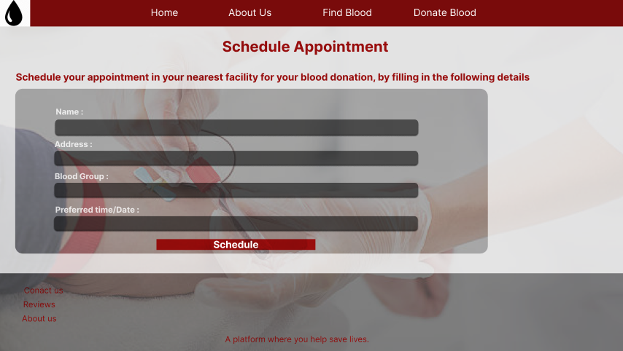

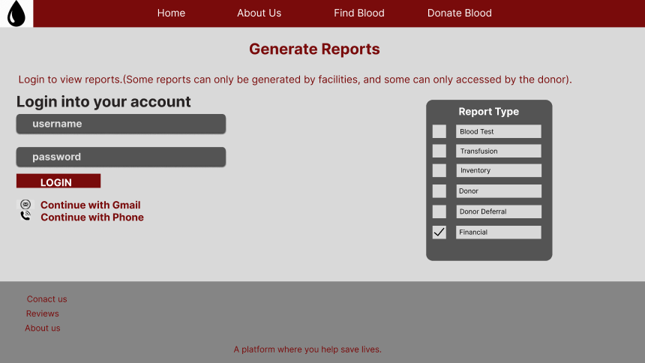

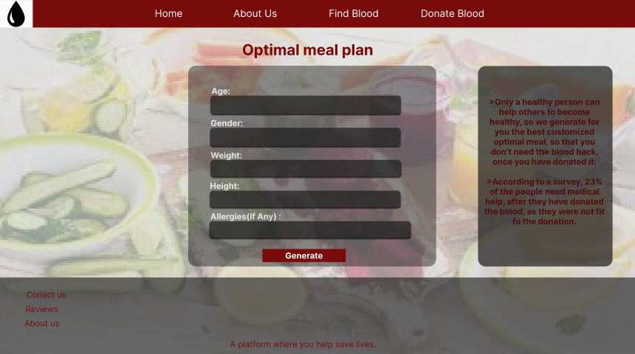

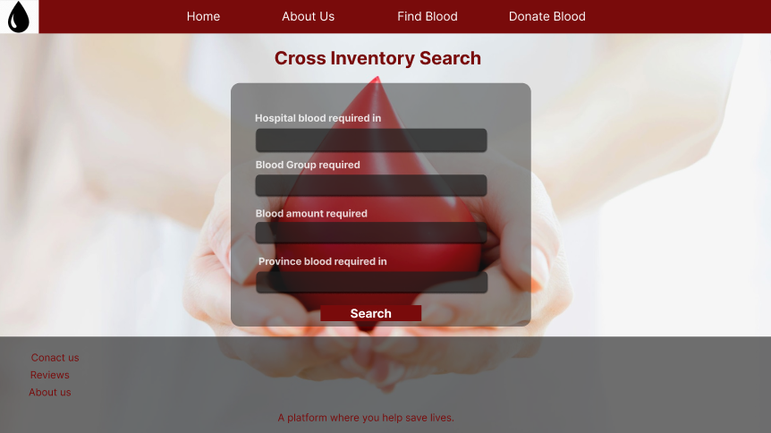

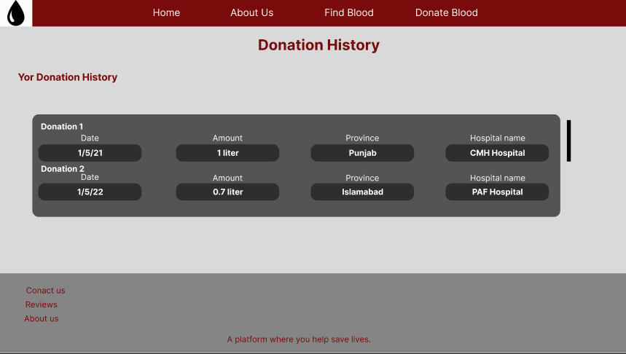

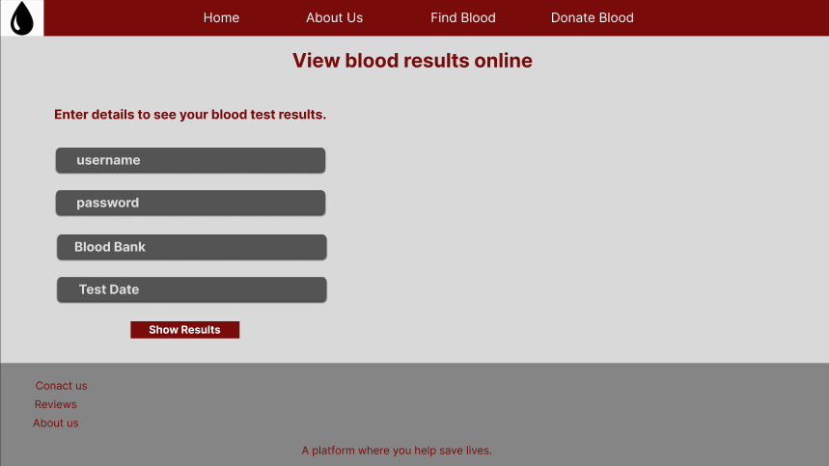

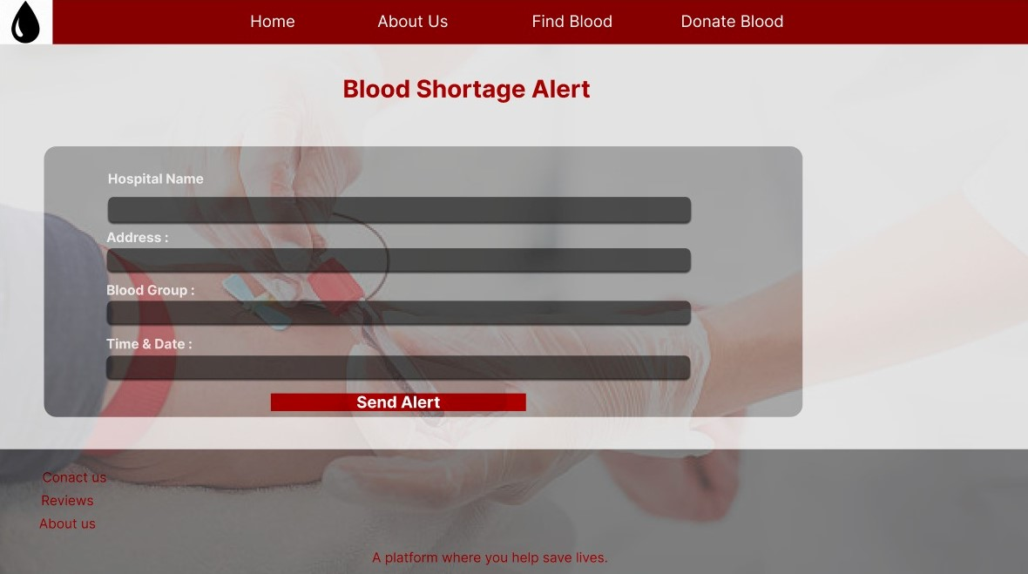

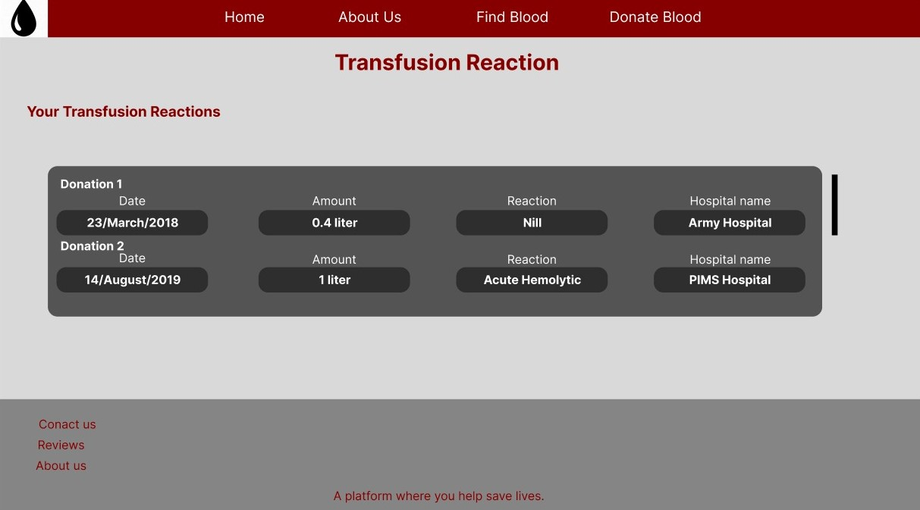

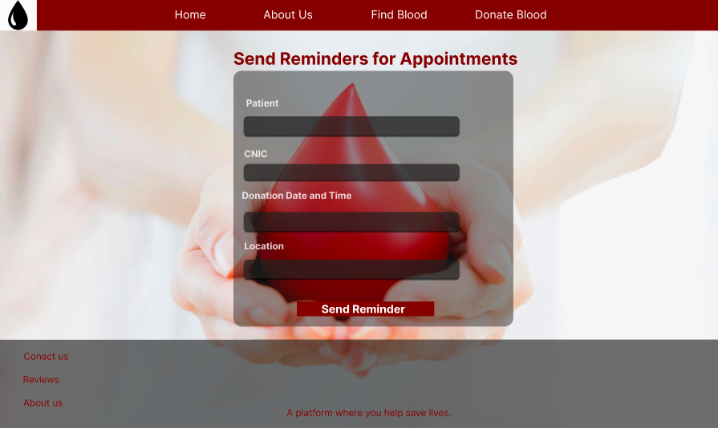

# Java FX Frames

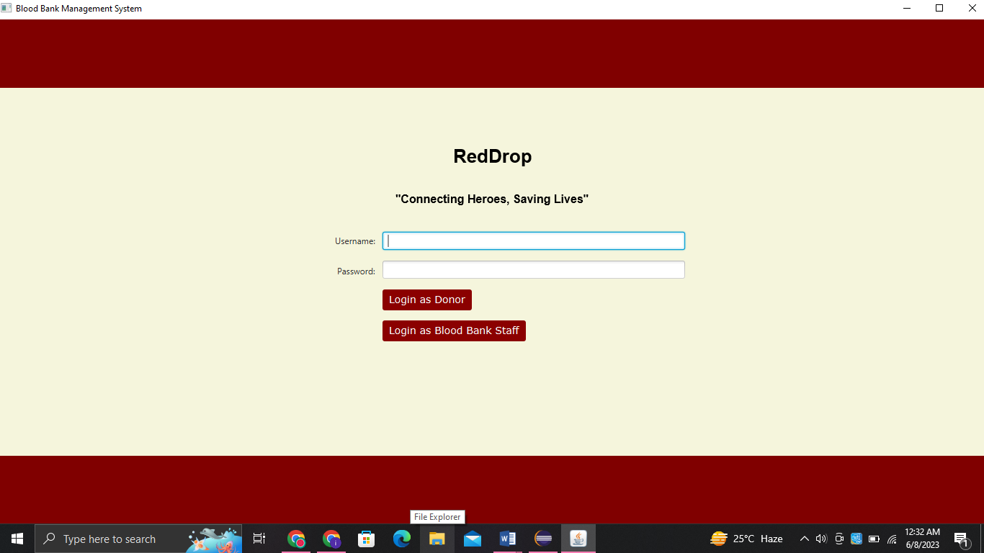

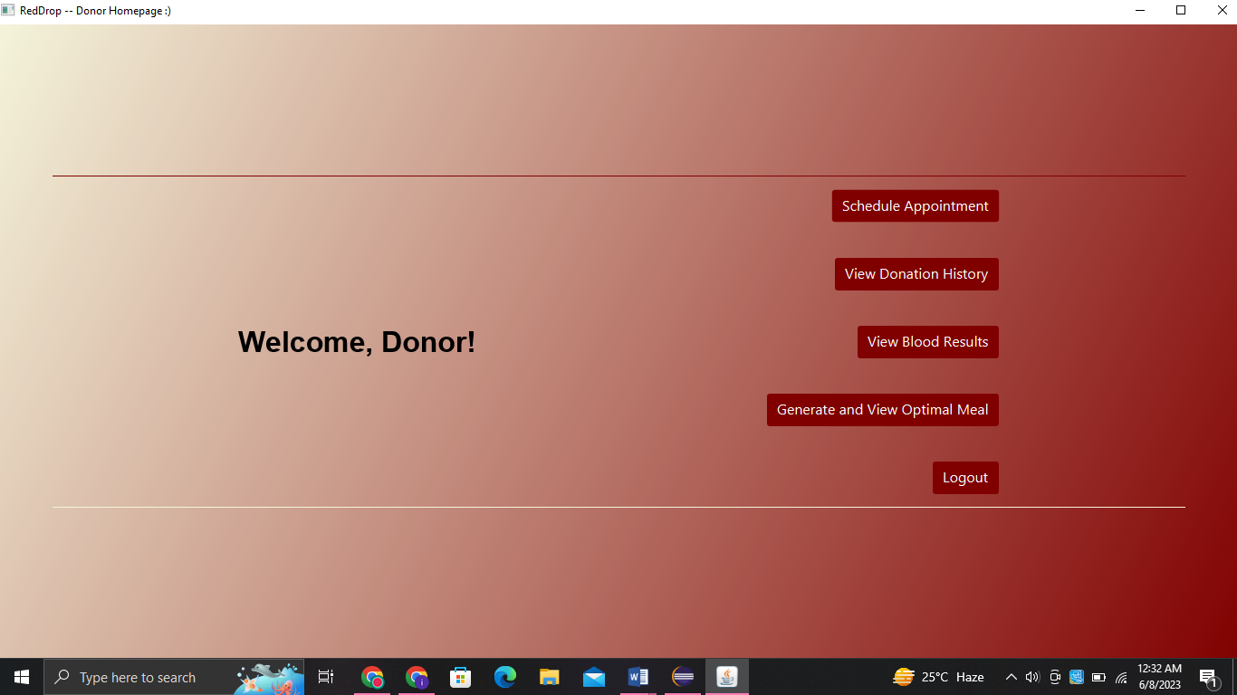

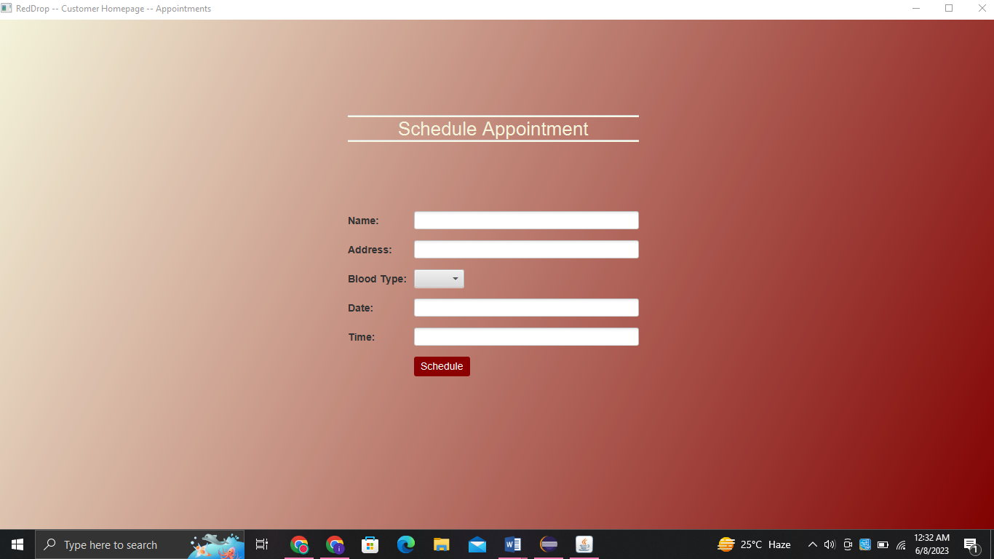

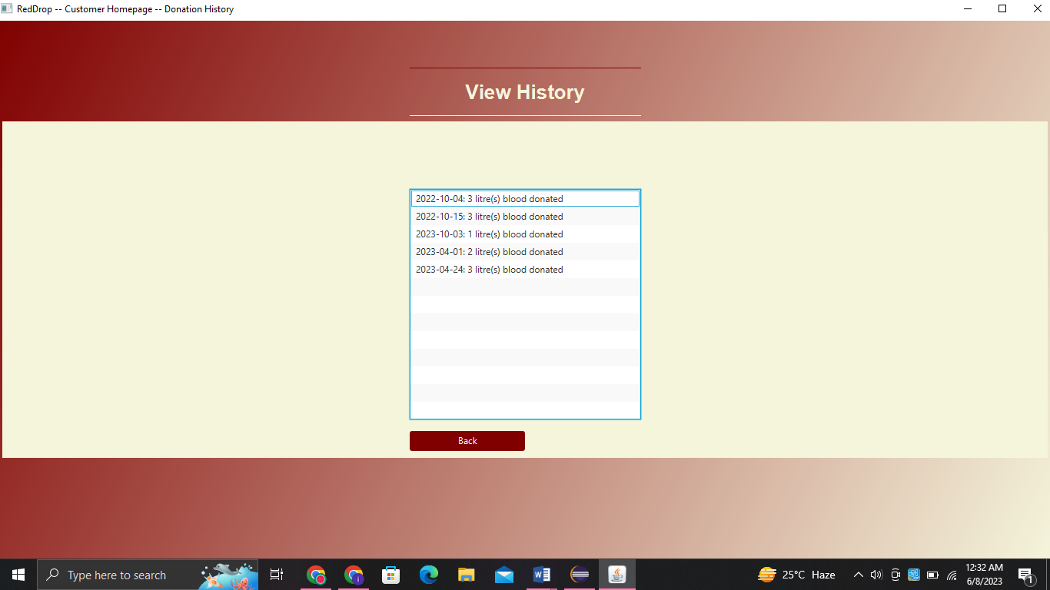

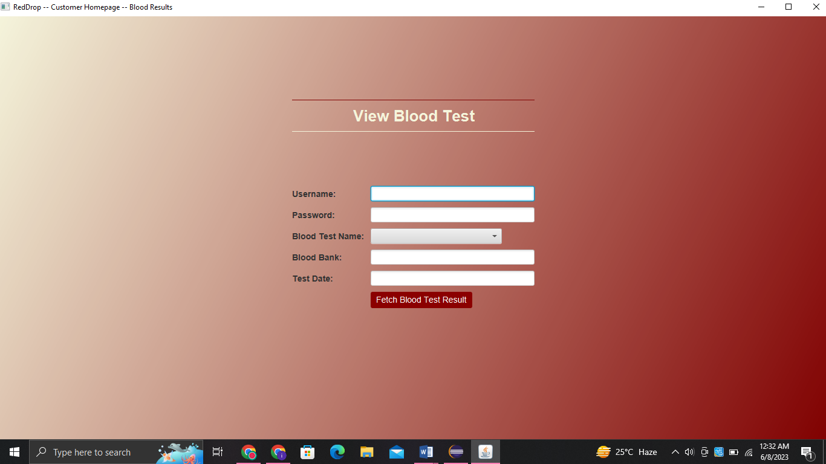

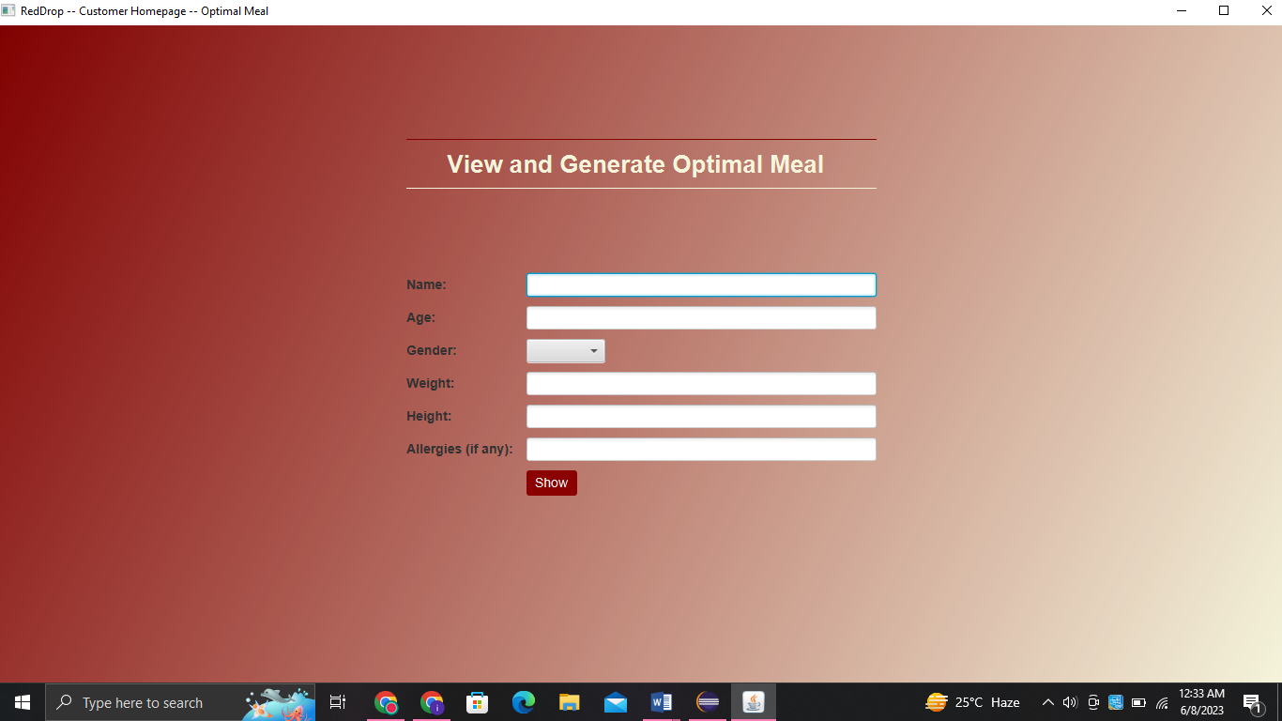

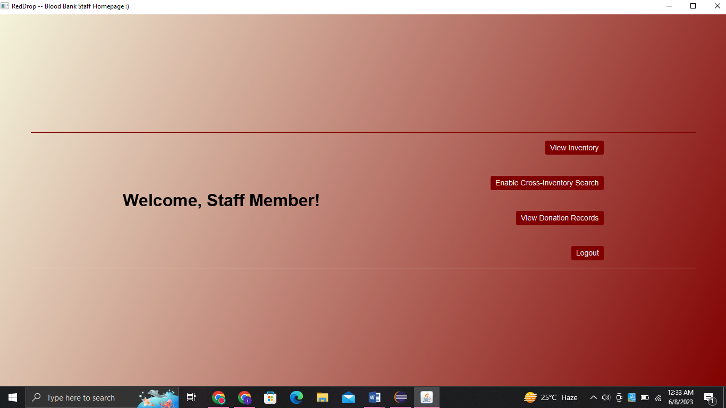

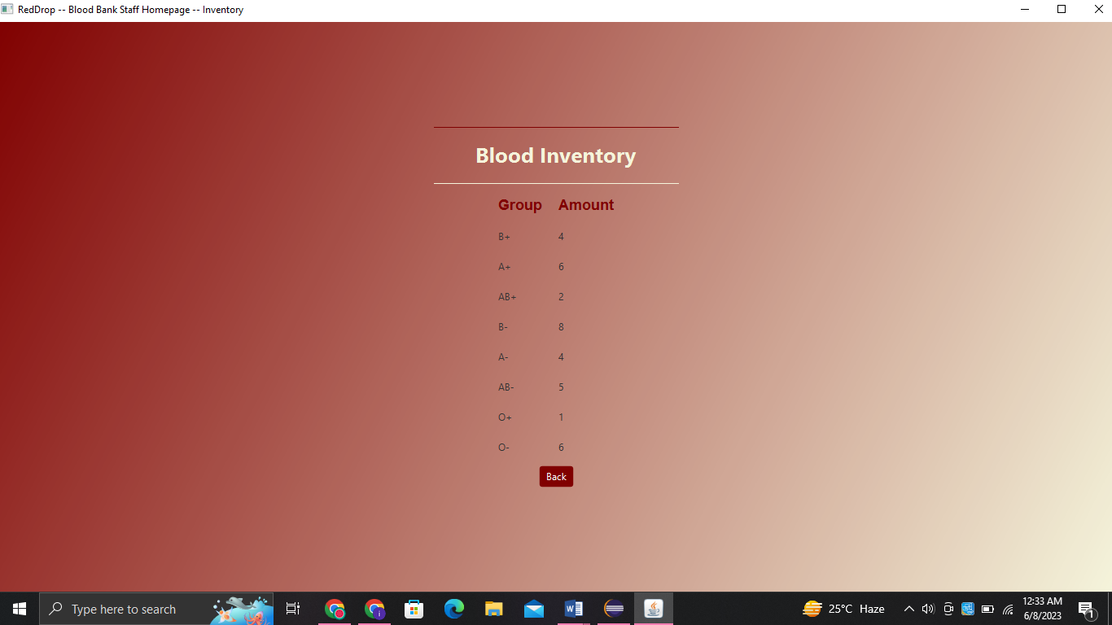

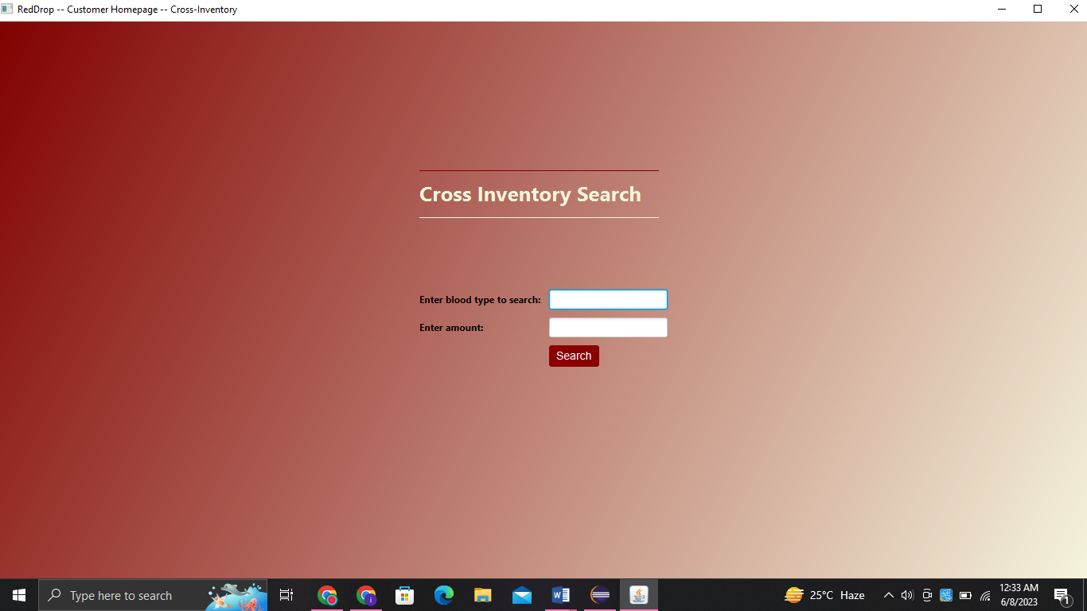

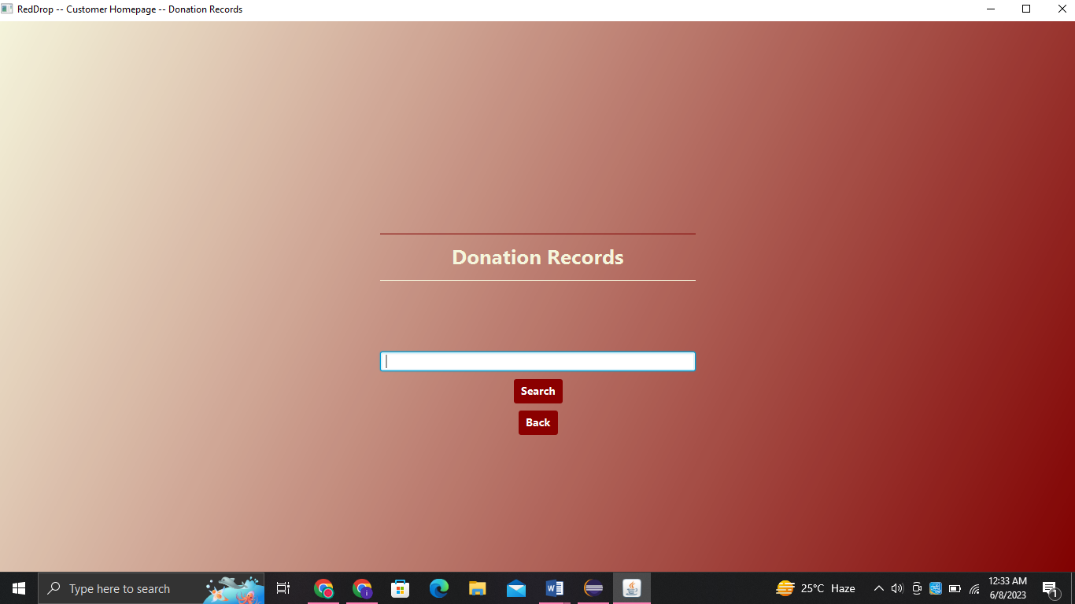

# System Sequence Diagrams (SSD)

## 8.1 Set Appointment

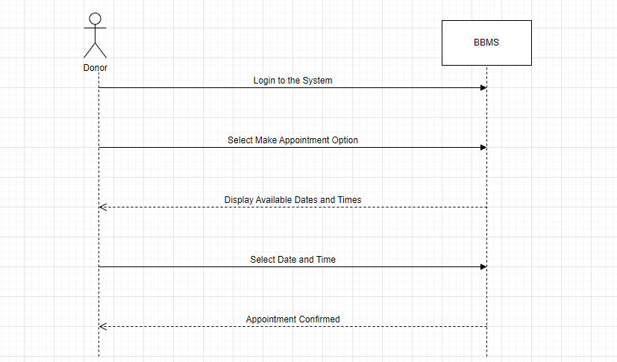

## 8.2 Generate Report

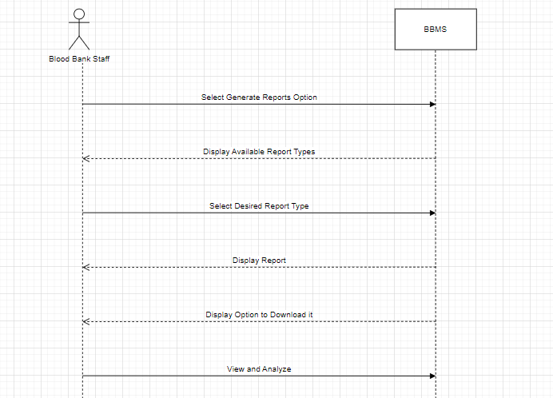

## 8.3 Display Optimal Meal

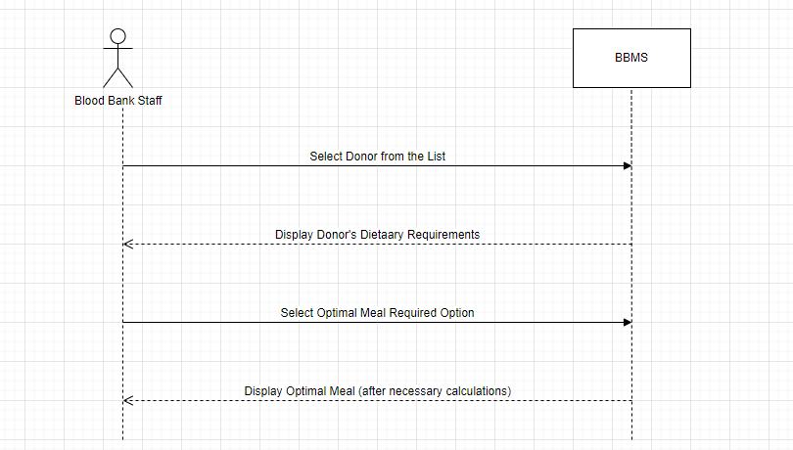

## 8.4 Enable Cross Matching Record

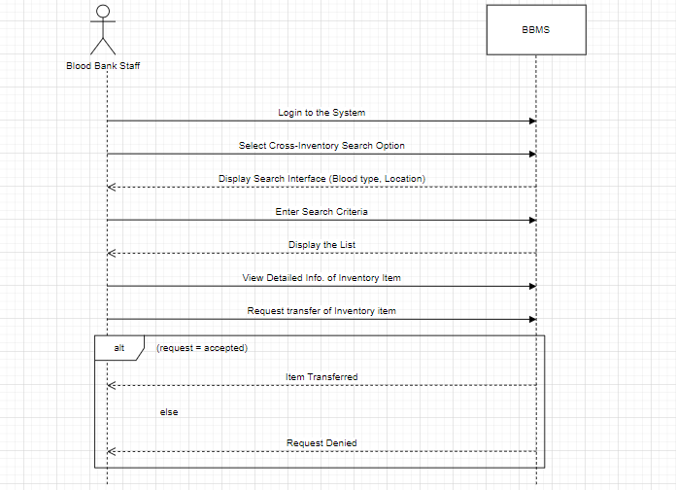

## 8.5 View Donation History

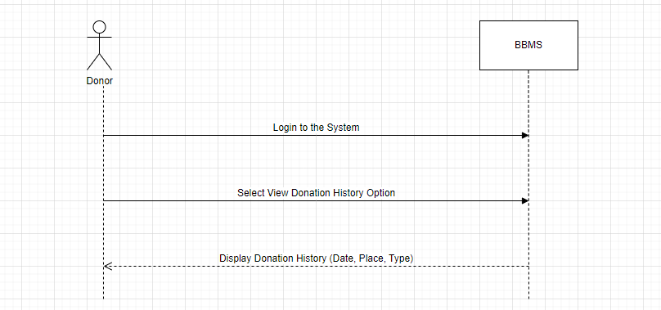

## 8.6 View Blood Test Result

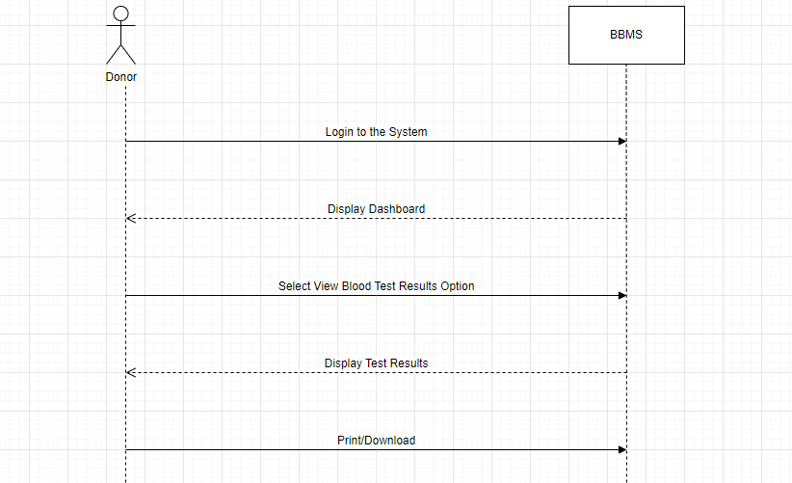

## 8.7 Send Alerts

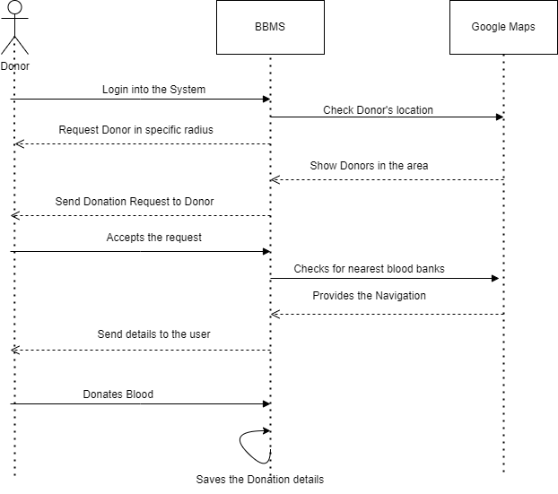

## 8.8 Maintain Transfusion Reaction

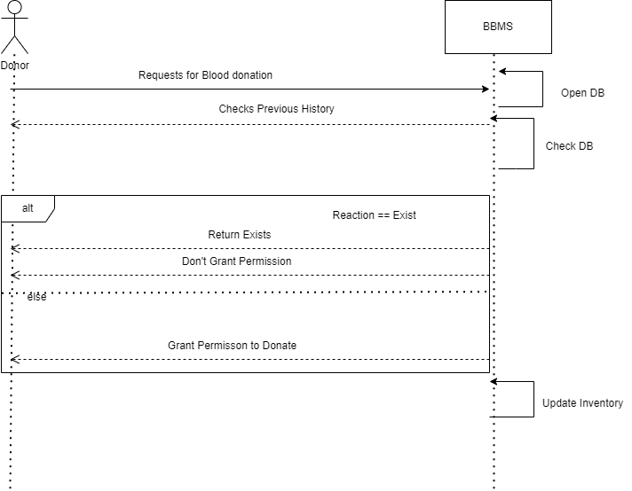

## 8.9 Set Reminder

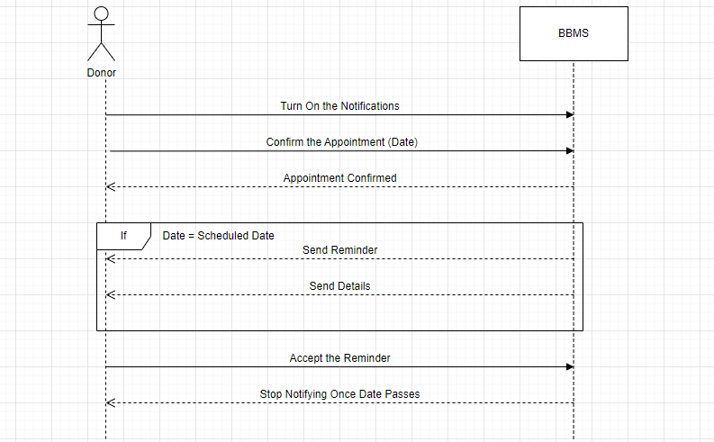

# Sequence Diagrams (SD)

## 



## Set Appointment

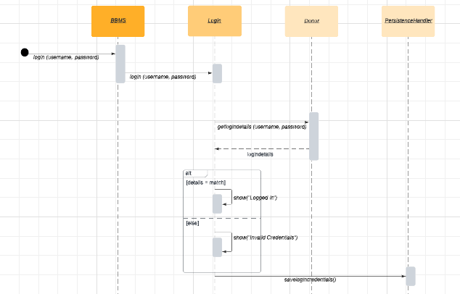

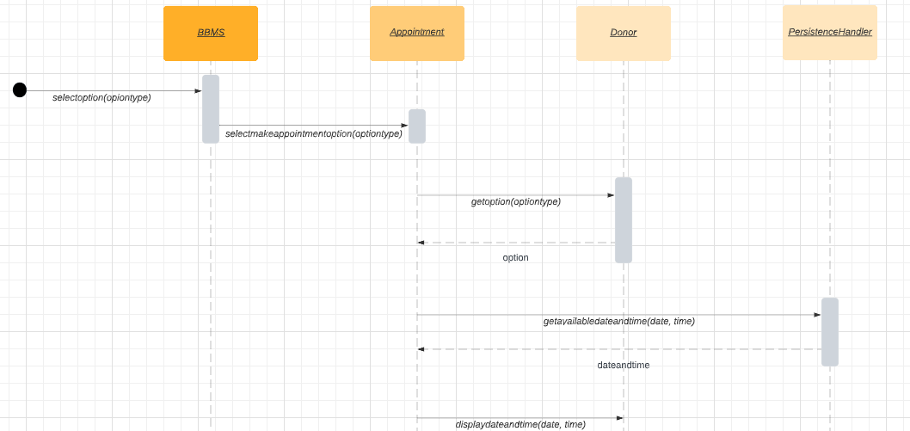

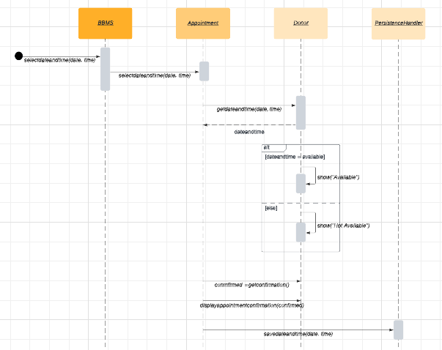

## 9.2 Generate Report

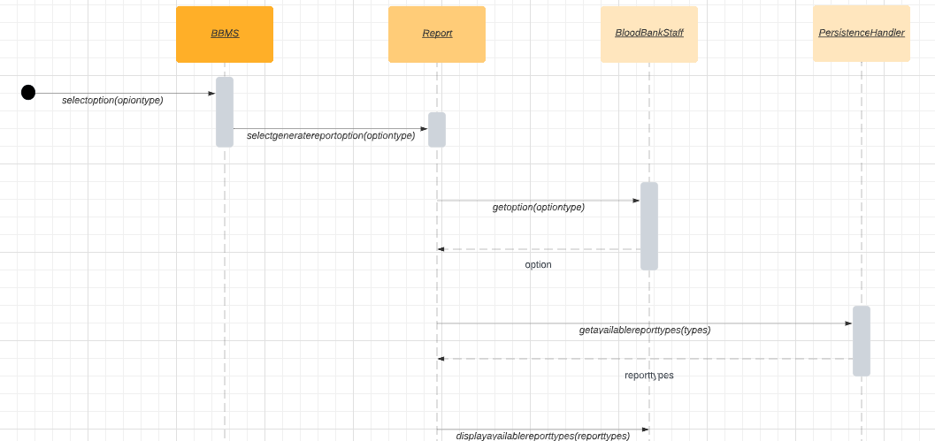

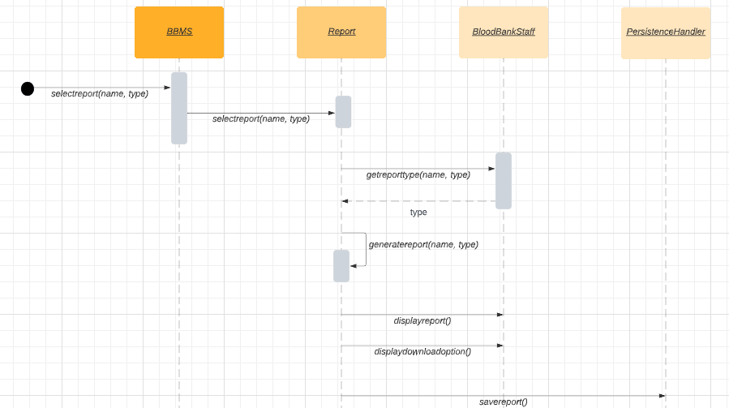

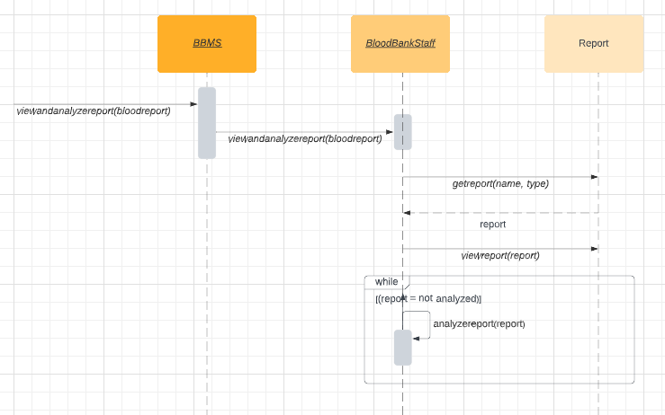



## Display Optimal Meal

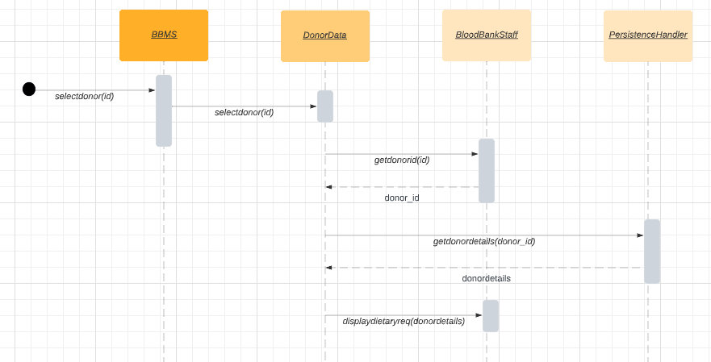

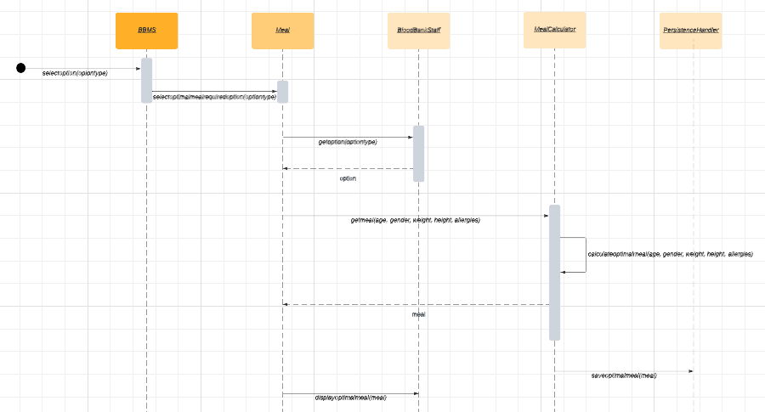

## Enable Cross-Matching Record



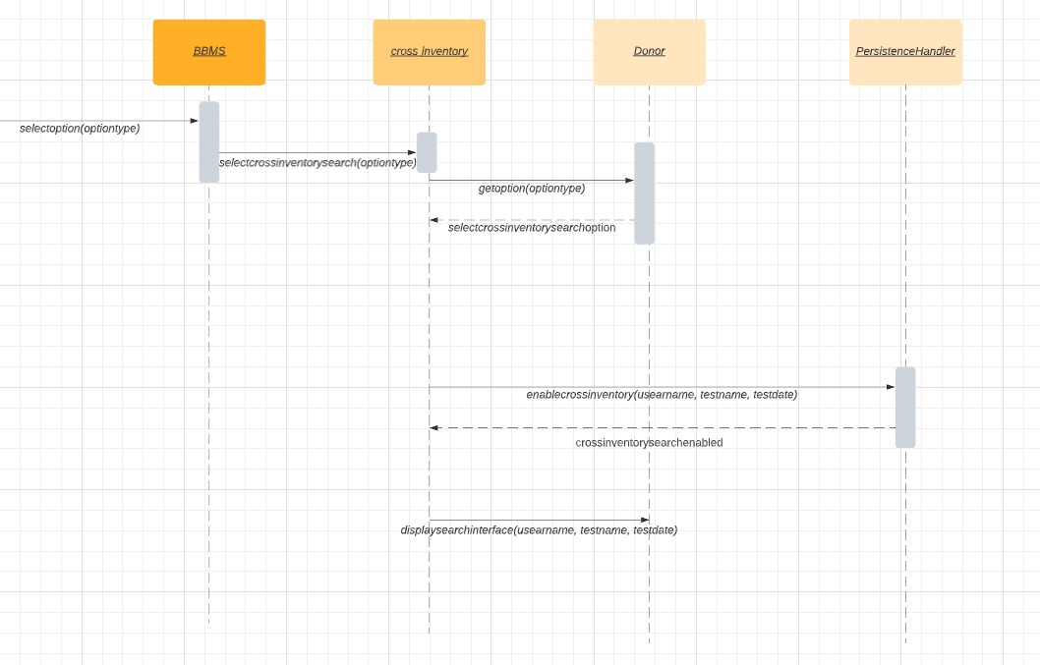

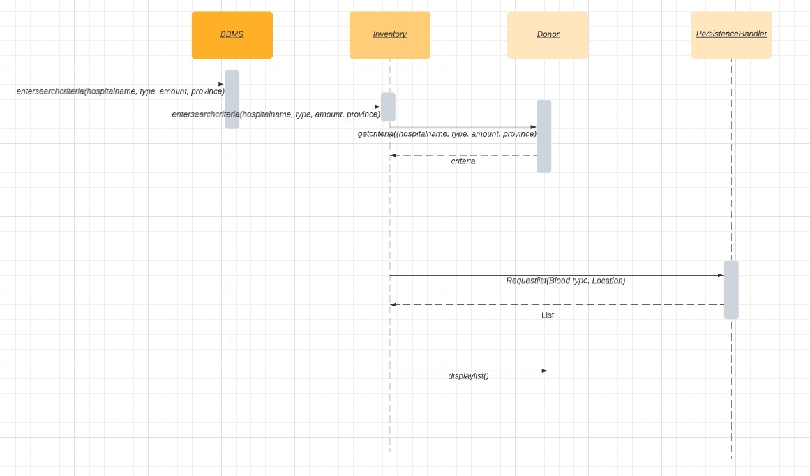

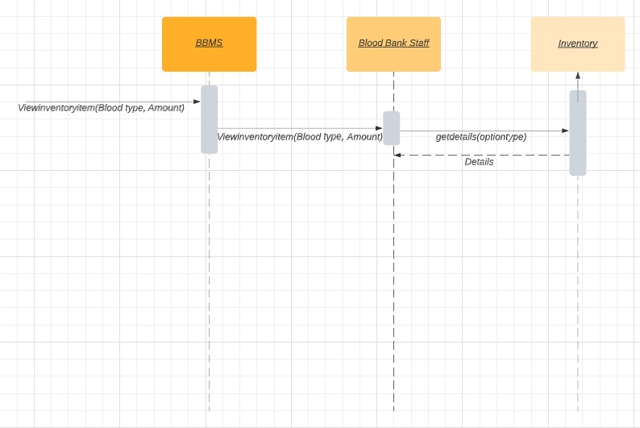

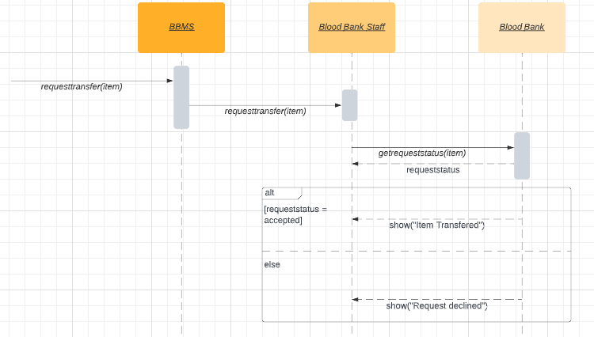

## View Donation History



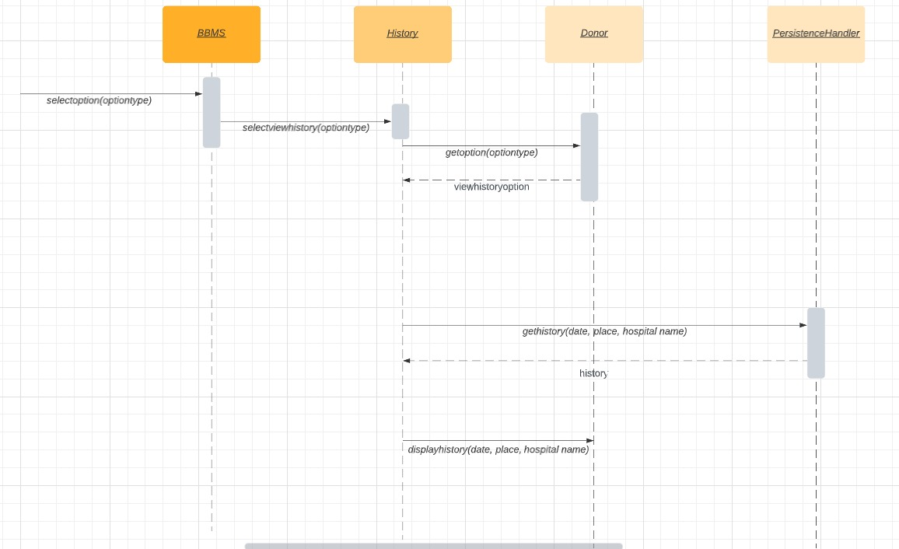

## View Blood Test Result

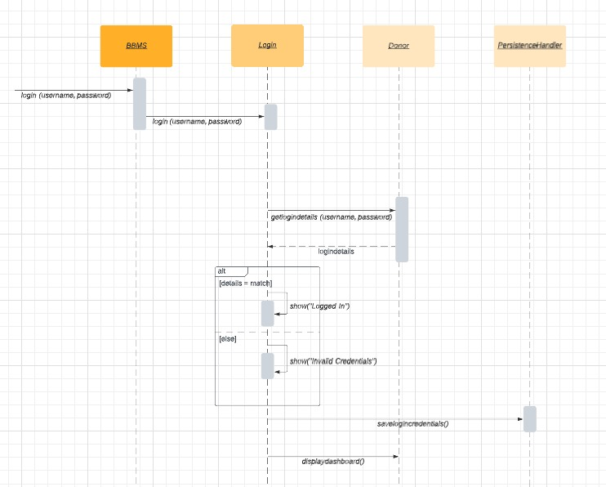

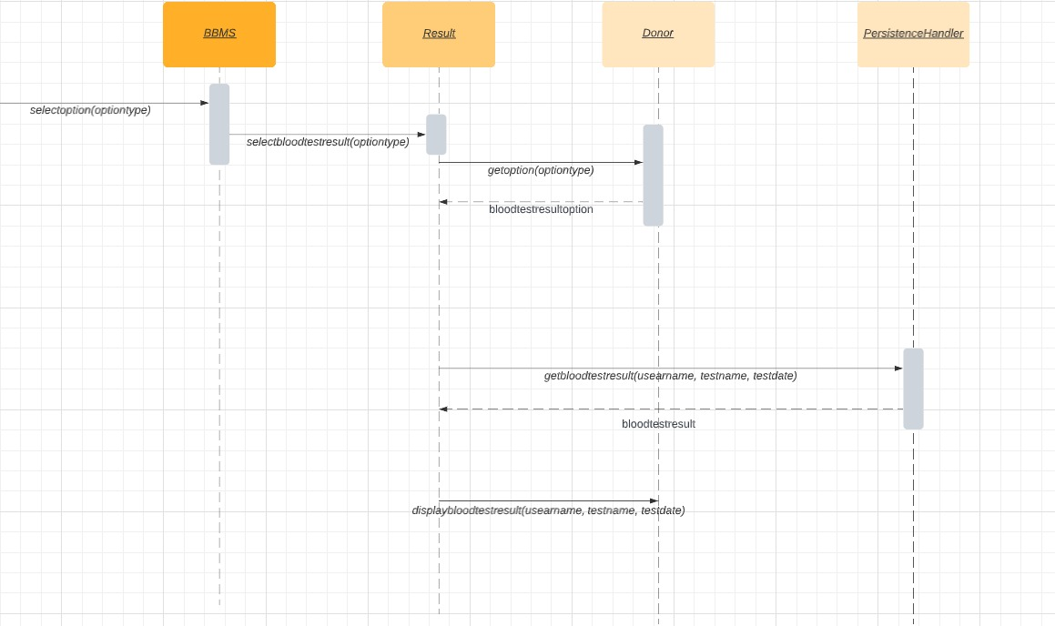

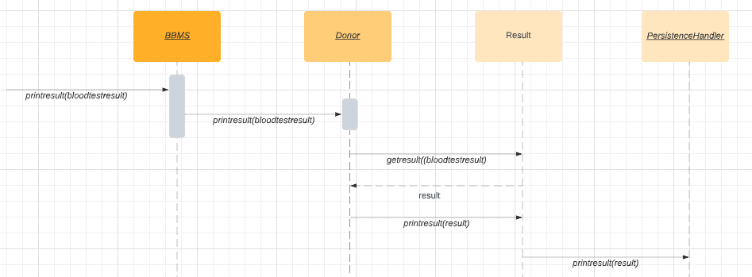

## Send Alerts

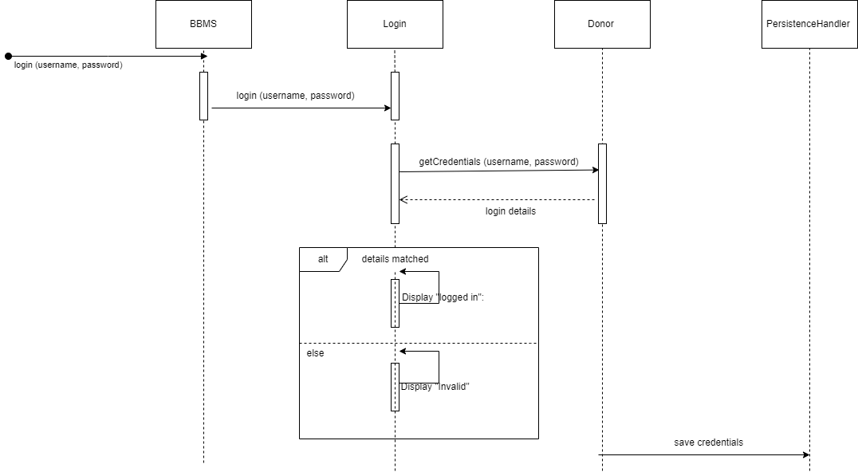

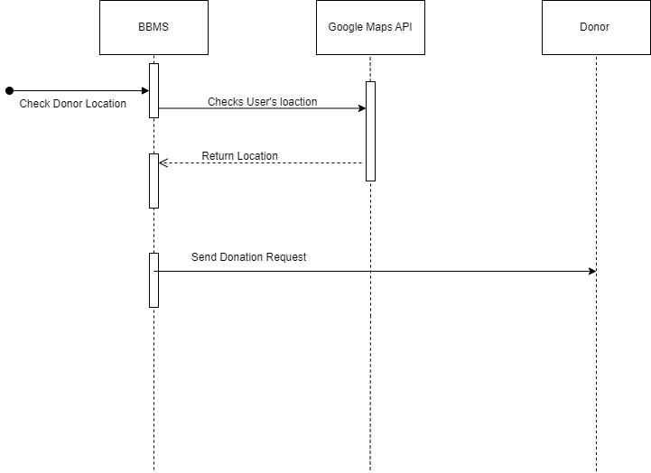

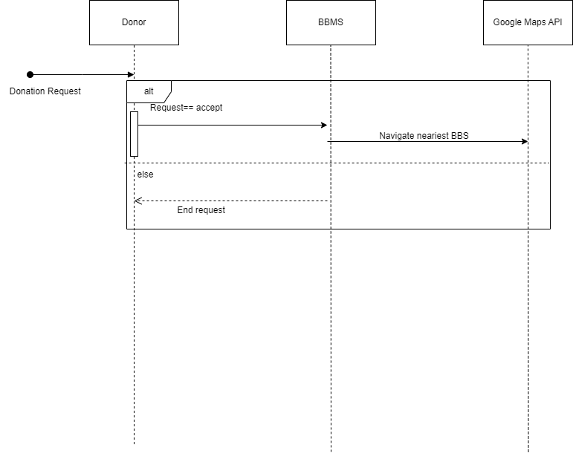

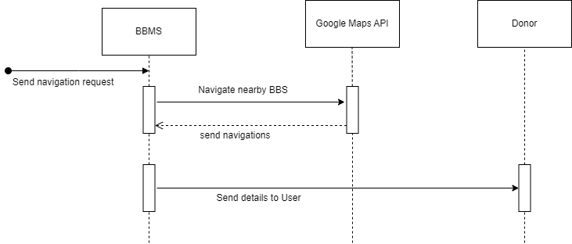

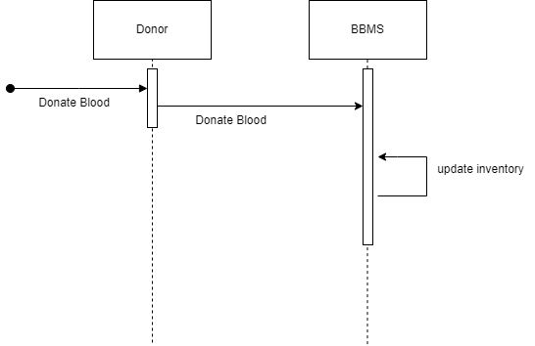

## Maintain Transfusion Reaction

## Set Reminder

# Domain Model (DM)

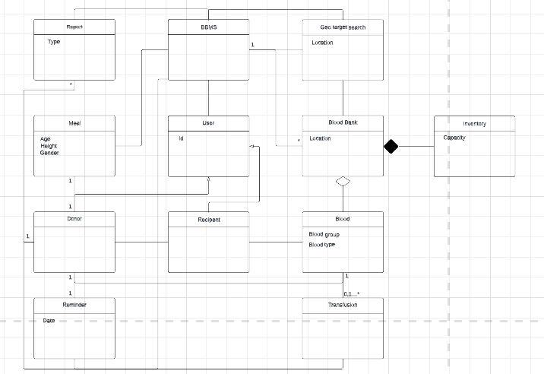

# Class Diagram (CD)